NUMBERS

SAMUEL SALAZAR ALZATE

FICHA : 3230441

EASY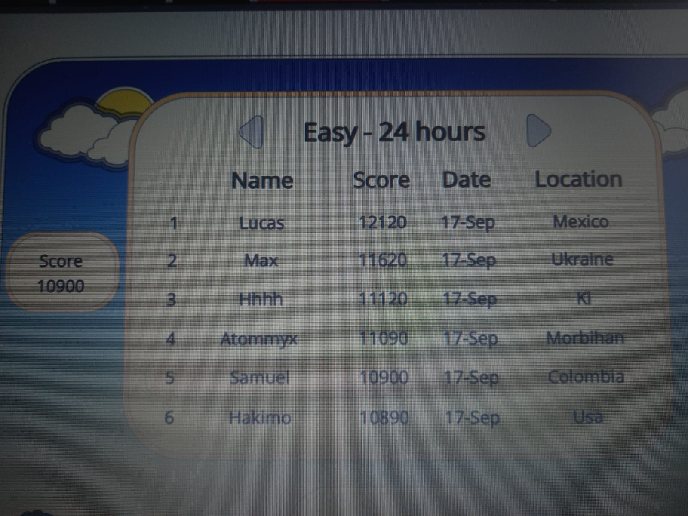

HARD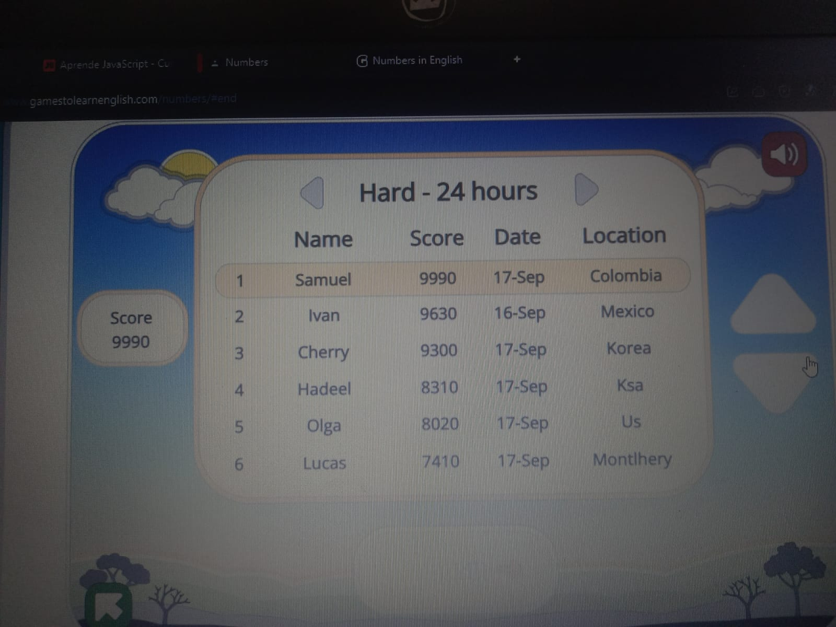

ORDINAL NUMBERS
